What's new in EhLib 9.1

(New features of your applications)

Brief description of new features in this version:
- New technology for storing the library's language resources
- New features in the TPivotGridEh component
- Dynamic calculation of found cells in SearchPanel
- Other changes and new features

New technology for storing the library's language resources
. 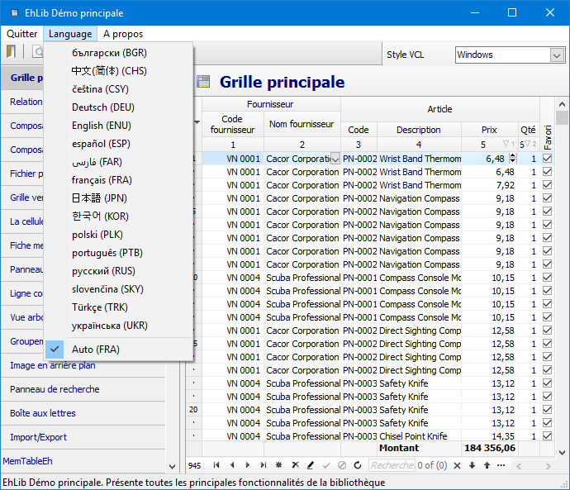
The new language resources storage technology library allows to load dynamically the library's language resources while the program is running.
The technology also allows you to create, store and download language resources not only for string library constants, but also for the string constants of your program.
The technology allows you to store language resources in an external file or link resources in an EXE file at compile time.
All string library constants that depend on the language are stored in the properties of the class TEhLibLanguageConsts (source files EhLibLangConsts.dfm + EhLibLangConsts.pas)
To access a class object, use the global function EhLibLanguageConsts: TEhLibLanguageConsts.
Versions of strings in other languages are stored in similar files with the corresponding name
EhLibLangConsts.ENU.dfm
EhLibLangConsts.FRA.dfm
EhLibLangConsts.RUS.dfm
EhLibLangConsts.UKR.dfm
...
in folder <EhLib archive >\LangResources\Res\
When installing the library in the IDE, the files in this folder should be copied to the folder <EhLib installed dir>\Lib\
If the file for your language is not in the folder, you can create it. To do this, copy the file EhLibLangConsts.ENU.dfm to a new file EhLibLangConsts.XXX.dfm where XXX is the three-letter language code. Using a text editor, change the text in the dfm file to the desired text.
The three-letter language code can be found in the table at the following address:
https://www.microsoft.com/resources/msdn/goglobal/default.mspx
Inside the file, also change the class name from TEhLibLanguageConsts_ENU to the new name TEhLibLanguageConsts_XXX (where XXX is the three-letter language code).
-----
While the program is running while changing the language, the algorithm finds the desired language file by three-letter code and loads into the EhLibLanguageConsts object as an external dfm resource or for embedded resources by the last three characters in the name of the resource TEhLibLanguageConsts_XXX.
Inside the program, the following code is used to change the language
LanguageResourceManagerEh.ActiveLanguageAbbr := 'Трехсимвольный код языка'.

To select the language automatically, use the following code
LanguageResourceManagerEh.ActiveLanguageAbbr :=
LanguageResourceManagerEh.AutoselectLanguage();

The language is chosen based on the variable - System.SysUtils.SysLocale.DefaultLCID
If the appropriate files or the built-in resource for the selected language was not found, the default language is downloaded from the built-in resource described in the EhLibLangConsts.dfm file. The EhLibLangConsts.dfm file links into the EXE file at compile time.
Working with language resources through external files
-----
When loading resources from a file, the algorithm looks for a file with a name:
<Местоположение EXE Файл>\Res\EhLibLangConsts.[XXX].dfm

Where XXX is a three-character language code.
You can configure the resource download folder by assigning a global variable
LanguageResourcesEh.LanguageResourcesFolder: String

-----
To use additional resources in your application, you must supply the EhLibLangConsts.XXX.dfm files along with the EXE file.
-----
The files in the Res folder are stored in the Utf8 encoding.
For the work of this technology in Delphi7-Delphi2005 for these versions of Delphi, similar files are stored in the Res.Ansi folder in the Ansi encoding.
-----
In the code of the program you can download a list of available resources for downloading the language using the code
LanguageResourceManagerEh.LoadListOfAvailableLanguages('EhLibLangConsts');

The algorithm will scan the \Res folder for EhLibLangConsts.[XXX].dfm files and fill in the internal property of EhLibLanguageConsts.LanguageList.
To access the list of available languages, use the property LanguageResourceManagerEh.LanguageList

Working with language resources through built-in resources
To link resources to the executable file, write the EhLibEmbeddedLangConsts module in the uses section of the main Form of your application. In this case, all available languages of the library will be built into the EXE file.
If you want to embed only part of the languages, instead of the EhLibEmbeddedLangConsts file, write the resource connection strings in the main Form of your application as follows:
{$R EhLibLangConsts.ENU.dfm}
{$R EhLibLangConsts.BGR.dfm}
{$R EhLibLangConsts.CHS.dfm}
{$R EhLibLangConsts.CSY.dfm}
{$R EhLibLangConsts.DEU.dfm}
…
These files should by default be located in a folder <EhLib installed folder>\Lib\
-----
Before the first change of language, specify in the LanguageResourceManagerEh object that you want to use the technology of embedded resources
LanguageResourceManagerEh.ResourcePlacement := lrpEmbeddedEh;

-----
In the code of the program, you can fill a list of available resources for downloading the language using next code:
LanguageResourceManagerEh.LoadListOfAvailableLanguages('TEhLibLanguageConsts');

The algorithm will scan the list of built-in resources for the availability of resources named TEhLibLanguageConsts_XXX and fill in the internal property of EhLibLanguageConsts.LanguageList.
To access the list of available languages, use the property LanguageResourceManagerEh.LanguageList

Create language resources for the language constants of your application
-----
You can also use the technology of storing language dependent constants to store the strings of your application.
For this
1. Create a class that inherits from TComponent and write in it in the published section whose properties the values in your application depend on the language.
(For an example, see the AppLangConsts.pas file from the Demo application DEMOS\MainDemo\ )
TApplicationLanguageConsts = class(TComponent)
..
public
constructor Create(AOwner: TComponent); override;
published
property Caption: String read FCaption write SetCaption;
property MenuFile: String read FMenuFile write FMenuFile;
end;

In the class constructor, load the values of the constants that will be used by default using next code:
constructor TApplicationLanguageConsts.Create(AOwner: TComponent);
begin
inherited Create(AOwner);
InitInheritedComponent(Self, TCustomControl);
end;

2. Create a resource dfm file (AppLangConsts.dfm) to store the property values of the class
object TApplicationLanguageConsts
Caption = 'EhLib Main Complex Demo'
MenuFile = 'File'
end

write the dfm file as the resource of your application
{$R AppLangConsts.dfm}

3.
Create files
AppLangConsts.ENU.dfm
AppLangConsts.BGR.dfm
AppLangConsts.CHS.dfm
AppLangConsts.CSY.dfm
AppLangConsts.DEU.dfm
...
By analogy with the files EhLibLangConsts.XXX.dfm
4. Once in the program code, create a variable for storing resources
FApplicationLanguageConsts := TApplicationLanguageConsts.Create(nil);

5. Once in the program code, register the resource in LanguageResourceManager
LanguageResourceManagerEh.AddLocalizableObject(FApplicationLanguageConsts,
FApplicationLanguageConsts.ClassName, 'AppLangConsts', 'ENU');

When changing the language, the WM_SETTINGCHANGE event is sent to all forms and controls.
-----
Default language resource
There is a concept - the built-in library language by default.
If you do not perform any actions to change the language in the application, then the default language resource in the library is used.
To change the default built-in language for all programs used:
- Copy the LangResources\Res\ EhLibLangConsts.XXX.dfm file to the installed library folder in the Lib\EhLibLangConsts.dfm file.
- Delete the first line of the file with the suffix _XXX in the name of the class so it will look like the following: object TEhLibLanguageConsts
- Recompile the library packages.
When the library is installed with EhLibInstaller.exe, the program performs this action automatically.
Demo projects using dynamic language resources loading
-----
For an example of using built-in and external resources, see the Demo project
DEMOS\LanguageResEmbeddedExternal\Project1.dpr
In the Unit1.pas file, you can comment out or uncomment the lines
{$DEFINE EMBEDDED_LANGUAGE_RESOURCES}
{$DEFINE EMBEDDED_LANGUAGE_RESOURCES_ALL}

To change the mode of using resources and understand the difference in working with built-in and external resources.
For detailed information on how to use the specified DEFINE definitions to change the resource usage mode, see the file Demos\LanguageResEmbeddedExternal\Info.Txt
-----
Another example of the use of dynamic loading of language resources can be seen in the Demo project - DEMOS\MainDemo\Project1.dpr
The main methods used in the project for working with language resources are as follows:
procedure AppLangConsts.InitUnit;
Registers the class TApplicationLanguageConsts in which the application's string resources will be stored.
procedure TForm1.InitLanguageRes;
Loads the list of available languages.
Activates the language from the Ini file if it was selected the last time the program was started.
procedure TForm1.BuildLanguageMenu;
Forms a menu of available languages based on the LanguageResourceManagerEh.LanguageList object
procedure TForm1.MenuItemSelectLanguage(Sender: TObject);
Loads files of a new language when the user selects another language in the menu.
procedure TForm1.ResourceLanguageChanged;
Assigns properties and form variables when the language has been changed.

New features in the TPivotGridEh component
Auto-save layout when resubmitting data
When updating the data, TPivotGridEh restores the column width, expanded / minimized groups and filters from the previous state.

Displaying / hiding total amounts in TPivotGridEh
- In the TPivotGridEh component, the Options property adds the values pgoGrandTotalColumnEh, pgoGrandTotalRowEh.
pgoGrandTotalColumnEh – Specifies whether to display the total column.
pgoGrandTotalRowEh – Specifies the need to display the total amount line.

New aggregate functions in TPivotGridEh
- TPivotGridEh adds new aggregate functions:
Product – The product of the values
StDev – Offset deviation
StDevp – Standard deviation
Var – Estimation of variance
Varp – Dispersion

Editing cells in TPivotGridEh
TPivotGridEh added the ability to change data cells. It is assumed that the structure of data generation is configured in such a way that the cell TPivotGridEh corresponds to the data cell in the source data and in the source database table. When the user changes the data in the cells of the event handler code TPivotGridEh.OnSetDataCellEditorValue should record the entered value in the source database table. In this case, the internal tables and TPivotGridEh aggregates calculate automatically.
To enable changes in TPivotGridEh cells, write the event handler TPivotGridEh.OnGetDataCellEditorParams.
For an example of using cell editing technology, see the Demo Project PivotGridEh.EditCells\Project1.dpr

Demo projects demonstrating the operation of the TPivotGridEh component
Demos\PivotGridEh.SimpleDemo
A simple example demonstrating how to create a structure and load data into TPivotDataSourceEh и TPivotGridEh.

Demos\PivotGridEh.EditCells
The example demonstrates how to allow the editing of cells in PivotGridEh and update the data in the source table when the data in the grid cells is changed.

Demos\PivotGridEh.PivotDataManager
The example demonstrates how you can create an unlimited number of summary reports and store their description, structure and layout in the database.
By running this project, you can add a new summary report, prescribe the connection setup and write a query to your database to evaluate the capabilities of the component when working with real data.

Demos\MainDemo
A simple example demonstrating how to create a structure and load data into TPivotDataSourceEh and TPivotGridEh is located in the PivotGrid menu of the main demonstration project of the MainDemo library.

Dynamic calculation of found cells in SearchPanel
When searching through SearchPanel, an automatic dynamic calculation of the found cells is performed.
The value found is displayed to the right of the search string.
While the calculation is in progress, the intermediate quantity found is displayed in parentheses.
The final amount found is displayed without brackets.
This feature works only when the Grid is connected to the DataSet of the TMemTableEh type.

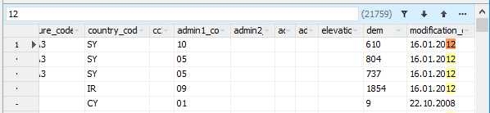

Other changes and new features

In TDBVertGridEh added functions to save / restore the state of the columns in the INI-file and Registry.

Save string settings to INI file or Registry
procedure SaveRowsLayout(ACustIni: TCustomIniFile; const Section: String); overload;
procedure SaveRowsLayout(ARegIni: TRegIniFile); overload;
procedure SaveRowsLayoutIni(const IniFileName: String; const Section: String; DeleteSection: Boolean);

The methods store the following string properties TFieldRowEh.Index, TFieldRowEh.RowLines, TFieldRowEh.Visible in an INI file or Registry

Save row settings and grid markup to INI file or Registry
procedure SaveGridLayout(ACustIni: TCustomIniFile; const Section: String); overload;
procedure SaveGridLayout(ARegIni: TRegIniFile); overload;
procedure SaveGridLayoutIni(const IniFileName: String; const Section: String; DeleteSection: Boolean);

Methods stores the settings for the strings described above, as well as the LabelColWidth property (Column width with row headings)

In TDBGridEh, the filter icon in the grid header is changed.
In TDBGridEh, when the column contains the values by which the entries in the grid are filtered, the dropdown form icon for selecting filter items is displayed as a funnel on the button.

