What's new in EhLib 9.0

(New features of your applications)

Brief description of new features in this version:
- New type of DropDown calendar with support for entering date and time
- New features in TPlannerCalendarPickerEh component
- New features in TPlannerControlEh
- Time divider of 5, 6, 10, 15, 30 and 60 minutes in TPlannerDayViewEh and TPlannerWeekViewEh components
- New properties and events in TPlannerXXXViewEh components (TPlannerDayViewEh, TPlannerWeekViewEh …)
- New ReadOnly property in the TPlannerDataItemEh class
- Collection of CellButtons in columns of DBGridEh (TColumnEh.CellButtons) and rows DBVertGridEh (TFieldRow.CellButtons) to create buttons in the cells of the grid operating without activation InplaceEditor text editor.
- Other features

The drop-down calendar to support the date and time
New control added to the library to display a drop-down calendar that can work in special modes:
- Input the date and time simultaneously,
- Input only the date
- Input only the time
The drop-down calendar starts work automatically in DBDateTimeEditEh component and in a text editor of and DBGridEh and DBVertGridEh components for TDateTimeField field.
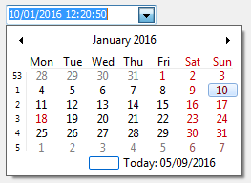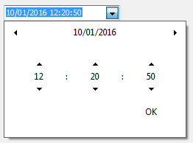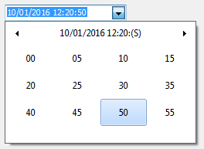
The drop-down calendar automatically hides the unused part of the date and time windows, depending on the EditFormat property (or DisplayFormat for TColumnEh in the DBGridEh and TFieldRow in the DBVertGridEh).

For example: For EditFormat = 'HH: NN' drop-down calendar is as follows and will allow only enter hours and minutes.

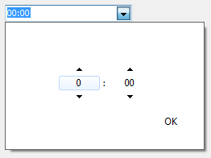

With global properties of library, you can configure the following capabilities a calendar.
- Highlight Weekend.
Property - ToolCtrlsEh.EhLibManager.DateTimeCalendarPickerHighlightHolidays: Boolean

- Highlight holidays.
For highlighting holidays and transfer of working days, use TWorkingTimeCalendarEh class.
Inherit TWorkingTimeCalendarEh class and override a method -
function IsWorkday(ADate: TDateTime): Boolean;
The method should return True if the ADate parameter is working days.
In the code of your program register your new object once for a working calendar using global procedure – RegisterGlobalWorkingTimeCalendar like this:
RegisterGlobalWorkingTimeCalendar(TMyWorkingTimeCalendarEh.Create(nil)).Free;
This method registers a class that controls weekends and holidays that affect the highlight of days in the calendar and the TPlannerCalendarPickerEh component.
The method returns old object that controlled working days. Usually the old object is destroyed immediately.

- To customize the color display holidays and weekends use next global object and property.
property PlannerCalendarPickerDrawStyleEh.HolidayBaseFontColor: TColor

- DropDown calendar also support Delphi VCL styles.

Here is a screenshot from PlannerEh.MainDemo project that shows what properties you can use to customize DropDown calendar.
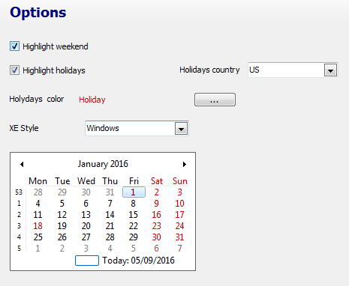

See the next Demo project to see how to work with DropDown Calendars:
<EhLib Archive>\Demos\CalendarPickerEh
unit Frame3_Options
unit Unit_ToolsDataModule
and
<EhLib Archive>\Demos\PlannerEh.MainDemo\
unit FrameOptions
unit Unit_ToolsDataModule

New features in TPlannerCalendarPickerEh component

Added support for displaying the holidays and weekends.  Added highlighting of a current day.  Added the ability to display a link to go to today. | 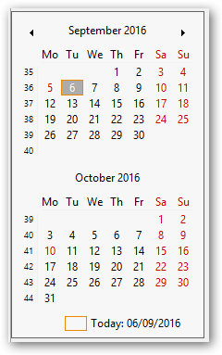

New features in TPlannerControlEh
Added highlighting the current day and the current time.

Support of XE styles were improved.

In TPlannerDayViewEh, TPlannerWeekViewEh, TPlannerMonthViewEh, TPlannerVertDayslineViewEh, TPlannerVertHourslineViewEh, TPlannerHorzHourslineViewEh, TPlannerHorzDayslineViewEh components
Added OnReadPlannerDataItem: TPlannerViewReadDataItemEventEh event:
TPlannerViewReadDataItemEventEh = procedure (PlannerControl: TPlannerControlEh;
PlannerView: TCustomPlannerViewEh; DataItem: TPlannerDataItemEh; var ReadDataItem: Boolean) of object;
In the event handler, you can determine whether you want to read a particular item / event from PlannerDataSourceEh.
Set ReadDataItem value to False to ignore the DataItem.
For example, you can set DataItem with a duration of more than one day will be not downloaded in the PlannerView.

An AllowedOperations ptoperty of TPlannerAllowedOperationsEh type was added in TPlannerControlEh
TPlannerAllowedOperationEh = (paoAppendPlanItemEh, paoChangePlanItemEh, paoDeletePlanItemEh);
The property specifies what kinds of operations on elements TPlannerDataItemEh can be performed.

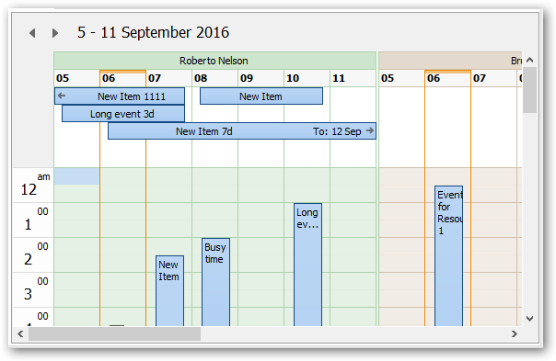
See a Demo project <EhLib archvie>\Demos\PlannerEh.MainDemo folder

Time divider of 5, 6, 10, 15, 30 and 60 minutes in TPlannerDayViewEh and TPlannerWeekViewEh components
In TPlannerDayViewEh and TPlannerWeekViewEh controls a BarTimeInterval property was added. The property have TPlannerBarTimeIntervalEh type.
TPlannerBarTimeIntervalEh = (pbti5MinEh, pbti6MinEh, pbti10MinEh, pbti15MinEh, pbti30MinEh, pbti60MinEh);
The property specifies the length (In minutes) of one time data row in the PlannerView.

New properties and events in TPlannerXXXViewEh components (TPlannerDayViewEh, TPlannerWeekViewEh …).
In all PlannerViews (TPlannerDayViewEh, ...) added next property:
property PopupMenu;
and event
property OnContextPopup;

property PlannerControl.TimeSpanParams.PopupMenu
New sub property PopupMenu was added in PlannerControl.TimeSpanParams property.
This menu is called when user right-click on an item SpanItem of PlannerView control.

PlannerControl.OnPlannerSpanItemContextPopup event
The PlannerControl.OnPlannerSpanItemContextPopup event is called before displaying a PopupMenu.
In the event handler, you can build and show the desired PopupMenu and assign a Handled to True or adjust TimeSpanParams.PopupMenu menu items.
For example, you can disable menu items for ReadOnly Event Item.
See example of using OnPlannerSpanItemContextPopup in the Project <EhLib archive>\Demos\PlannerEh.MainDemo\
Unit FrameOne.pas

New ReadOnly property in the TPlannerDataItemEh class
In TPlannerDataItemEh added ReadOnly property.
Set ReadOnly to True for PlannerDataItem elements, which cannot be changed in PlannerControl.

Collection of CellButtons in columns of DBGridEh (TColumnEh.CellButtons) and rows DBVertGridEh (TFieldRow.CellButtons) to create buttons in the cells of the grid operating without activation InplaceEditor text editor.
New collection CellButtons was added in Column of DBGridEh (TColumnEh) and FieldRow of DBVertGridEh (TFieldRow).

The collection contains TCellButtonEh type elements. CellButton element specifies the button in the grid cell. CellButton element is similar to EditButton element (edit button), but unlike the EditButton is pressed without opening a text editor. Set of TCellButtonEh properties are similar to a list of properties in TEditButtonEh and have additional properties.
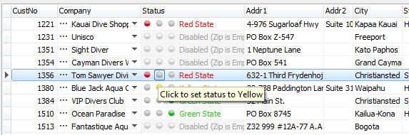

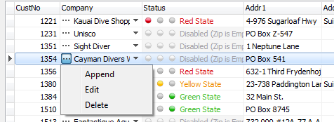

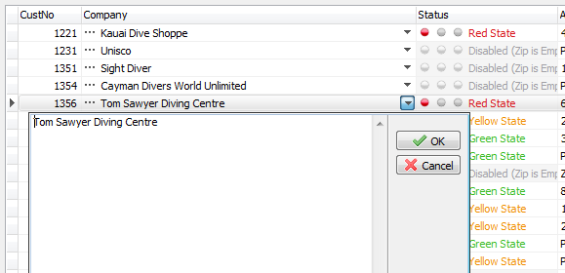

TCellButtonEh has next additional properties and events:
New properties:
property HorzPlacement: TEditButtonHorzPlacementEh default ebhpRightEh;
It specifies the location of the buttons in the grid cell horizontally.
TEditButtonHorzPlacementEh type has the following values:
ebhpLeftEh - button is aligned to the left edge of the cell.
ebhpRightEh - button is aligned to the right edge of the cell.

New events:
property OnGetEnabledState: TCellButtonGetEnabledStateEventEh;
type TCellButtonGetEnabledStateEventEh = procedure(Grid: TCustomDBAxisGridEh; AxisBar: TAxisBarEh; CellButton: TCellButtonEh; var ButtonEnabled: Boolean) of object;
The event is called for every record in the grid. You can set ButtonEnabled property to set that particular record button is not available for the press. In this case, it will be drawn in the Disabled styles.

property OnDraw: TDrawCellButtonEventEh;
type TDrawCellButtonEventEh = procedure(Grid: TCustomDBAxisGridEh; AxisBar: TAxisBarEh; CellButton: TCellButtonEh; Canvas: TCanvas; Cell, AreaCell: TGridCoord; const ARect: TRect; ButtonDrawParams: TCellButtonDrawParamsEh; var Handled: Boolean) of object;
The event is called when rendering the button in a grid cell. In the event you can specify the parameters of the rendering by assigning the appropriate properties in ButtonDrawParams parameter,
or you yourself can draw the image button,
or you can call the default method of rendering - CellButton.DefaultDrawEditButton.
In the second and third case, set the Handled parameter to True to prevent the grid drawing the cell after the event.

property OnMouseClick: TMouseCellButtonEventEh;
This event is fired when pressing the mouse button.

property OnMouseDown: TMouseCellButtonEventEh;
Event is fired when the button is clicked with the mouse.

See example of using CellButtons in the Project
<EhLib archive>\ Demos\DBGridEh.CellButtons\Project1.dpr

Other features
Search in a mode of “Begins with” in search panel.
In DBGridEh.SearchPanel added CellBeginsWithMode property of type Boolean. In DBGridEh.Search Panel.OptionsPopupMenuItems added gsmuBeginsWithEh value.

In TDBVertGridEh.SearchPanel added CellBeginsWithMode property of type Boolean. In TDBVertGridEh.Search Panel.OptionsPopupMenuItems added gsmuBeginsWithEh value.
These properties allow you to enable the ability to search in SearchPanel in "From the beginning of the cell" mode. In this mode, the searching string should be located at the beginning of the cell value.

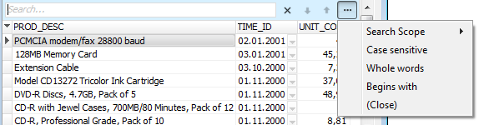

Selecting of rows in DBGridEh.DataGrouping mode by pressing the group row in the indicator section.

In DBGridEh.DataGrouping mode, the user can select all child records data by clicking the mouse on the contrary group row in the indicator section.
