What's new in EhLib 8.2

(New features of your applications)

Brief description of new features in this version:
- New features in SearchPanel of TDBGridEh
- SearchPanel in TDBVertGridEh
- Fill Right Empty part of TDBGridEh with cells like patterns
- Event to customize and draw title cells including SupperTitle in MuliTitile mode.
- Painting editor buttons (EditButtons) with a transparent background.

New features in SearchPanel of TDBGridEh
New ellipses "..." button is added in TDBGridEh SearchPanel. Click on the button opens a drop down menu where you can choose the following search options in the grid:
- Search area: The current column or the entire grid.
- Search with or without text case.
- Search complete words or parts of words.
If the found text is hidden behind the border of the cell, the number of hidden found matches is displayed in a yellow box at the top right side of the cell .
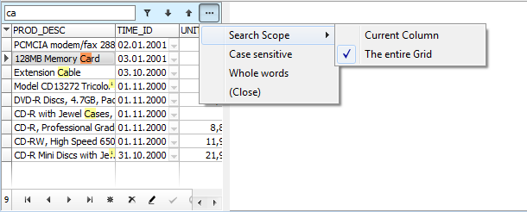

New sub-properties added and the DBGridEh.SearchPanel property:
OptionsPopupMenuItems: TDBGridSearchPanelOptionsMenuItemsEh
Specify a list of elements of the drop-down menu that appears on click of Search Options ("...") button in SearchPanel.
TDBGridSearchPanelOptionsMenuItemsEh type may comprise the following meanings
gsmuSearchScopesEh – Search Area.
gsmuCaseSensitiveEh – Search in case-sensitive mode.
gsmuWholeWordsEh – Search by full word.
SearchScope: TDBGridSearchPanelScopeEh
Specifies the search area that runs by default in Search Panel
The property can be one of the following values:
gssCurrentColumnEh – Search in the current column.
gssEntireGridEh – Search in the entire grid.
CaseSensitive: Boolean
Specify a case sensitivity of searching.
WholeWords: Boolean
It specifies that the search in the SearchPanel must be performed in full word mode.

SearchPanel in TDBVertGridEh
The ability to search via SearchPanel is added in the TDBVertGridEh component, as is done in TDBGridEh.
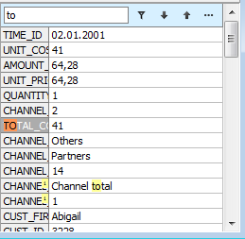
A SearchPanel property is added in the TDBVertGridEh component with next sub properties:
Enabled: Boolean;
Search Panel is available in DBVertGridEh. The Search Panel can be hidden for the user if PersistentShowing = False.
FilterEnabled: Boolean;
Specifies that Search Panel results can be filtered.
FilterOnTyping: Boolean;
Specifies that filtering must be performed as a text is being typed in the Search Panel editor.
PersistentShowing: Boolean;
Specifies that SearchPanel is always visible in TDBVertGridEh. If PersistentShowing = False, the user can display and activate SearchPanel by pressing the key combination defined by a ShortCut property.
ShortCut: TShortCut
Sets the key combination by which a focus transfer to the Search Panel text editor.
CaseSensitive: Boolean
Specifies the text case sensitivity when searching via Search Panel.
WholeWords: Boolean
Specifies that the search must be performed by the whole words when searching via Search Panel.

Fill right empty part of TDBGridEh with cells like patterns
New properties are added in the DBGridEh class that allows to fill the empty space at the right part of the grid with cells like pattern. See a screenshot.
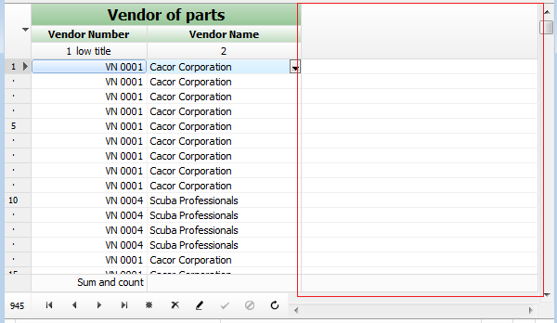
A new subproperty HorzEmptySpaceStyle of TDBGridHorzEmptySpaceStyleEh type is added to the DBGridEh.GridLineParams property.
A property can have the following values:
deshNonEh – Do not fill the empty space to the right part of the grid.
deshExtendTitleWideSpaceEh – Fill in the blank right header area of the grid.
deshExtendGridWideSpaceEh – Fill in the blank right header area and data part of the grid.

Event to customize and draw title cells including SupperTitle in MuliTitile mode.
New events OnGetTitleParams and OnDrawTitleCell are added to DBGridEh component to customize and render the header of the grid columns. These events convenient to use for the top-level headers in MultiTitle mode because to TDBGridEh have no separate static objects to configure the top-level headers.
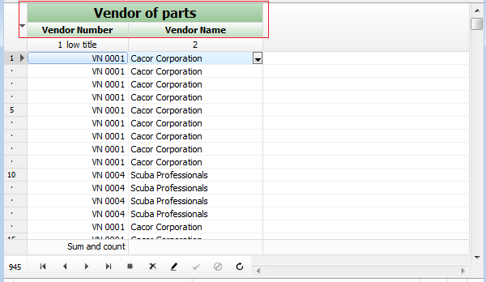
New events in the DBGridEh component:
OnGetTitleParams: TDBGridGetDrawTitleParamsEventEh
TDBGridGetDrawTitleParamsEventEh = procedure(Grid: TCustomDBGridEh; Params: TDBGridDrawTitleCellParamsEh) of object;
The event is called before rendering the column header. In the event you can change the properties of an Params object.
Params has a lot of properties. The main properties that can be changed are following:
Font: TFont – Title font.
Color: TColor – Background color.
SecondColor: TColor – Second background color. Used in GradientFill mode.
ForeInsideRect: TRect – The size of the inside of the cell contents. DrawTitleCellBackground method reduces the size of the relative size of the cell after the 3D rendering of the cell border. You can also reduce the size of the area if you want to draw additional information in the left or right side of the header cell.

OnDrawTitleCell: TDBGridDrawTitleEventEh
TDBGridDrawTitleEventEh = procedure(Grid: TCustomDBGridEh; ACanvas: TCanvas; const ARect: TRect; Params: TDBGridDrawTitleCellParamsEh; var Processed: Boolean) of object;
The event is called before rendering the column header. You write the code to draw the header itself and set the Processed to True to prevent standard code for rendering.
Or you can change the values in the Params parameter to change the style of the header.
You can also call the standard methods for rendering the title:
DrawTitleCellBackground – rendering title cell background.
DrawTitleCellForeground – rendering the content of title cell.

For an example of using events see the next demo project:
DEMOS\DBGridEh.CustomTitleDraw

Painting editor buttons (EditButtons) with a transparent background.
New ability to display the edit buttons in transparent background mode is added to the such controls as TDBEditEh, TDBNumberEditEh, TDBDateTimeEditEh etc. and in the TDBGridEh and TDBVertGridEh. In this mode, the edit button shows only a foreground icon.
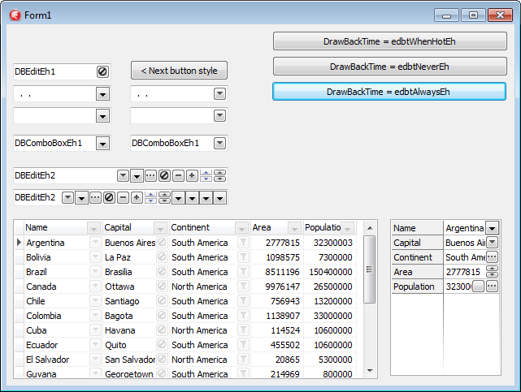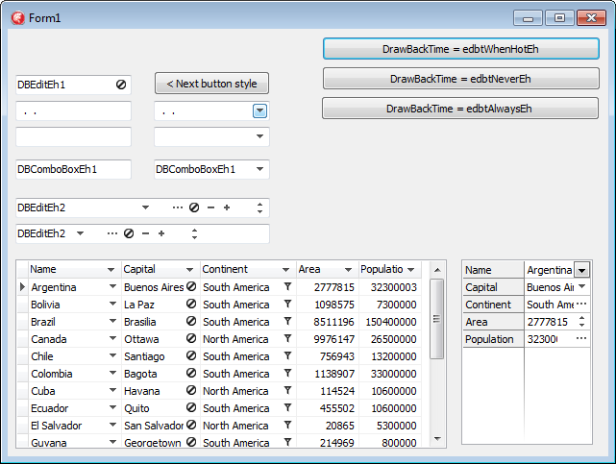
Limitations and Compatibility:
- Not all types of buttons correctly support the drawing mode. For example such types as ebsDropDownEh ebsUpDownEh use Windows style to draw data and they can’t draw Background and Foreground part separately. For these buttons use alternative types - ebsAltDropDownEh and ebsAltUpDownEh.
- Transparent back drawing does not work when the button have ebsGlyphEh style and the picture is in the Glyph property. To get around the restriction move a picture in TImageList component and fill EditButton.Images property.
Use the following types of properties to set a transparent background for Buttons:
Types
TEditButtonDrawBackTimeEh = (edbtAlwaysEh, edbtNeverEh, edbtWhenHotEh);
edbtAlwaysEh – Always draw the button background
edbtNeverEh – Never draw the button background
edbtWhenHotEh – Draw button background when a mouse cursor is over the button.
Properties
property TColumnEh.EditButton.DrawBackTime: TEditButtonDrawBackTimeEh
property TColumnEh.EditButtons[i].DrawBackTime: TEditButtonDrawBackTimeEh
Sets a drawing mode for button background in the column editor.

property TColumnEh.EditButton.DrawBackTimeStored: Boolean
property TColumnEh.EditButtons[i].DrawBackTimeStored: Boolean
Determines that the value of a DrawBackTime property is persistent and does not depend on the value of other properties. If DrawBackTimeStored = False, the default value for the DrawBackTime property is taken from TDBGridEh.ColumnDefValues.EditButtonDrawBackTime property.

property TDBGridEh.STFilter.FilterButtonDrawBackTime: TEditButtonDrawBackTimeEh
Sets a drawing mode for button background of STFilter buttons.

property TDBGridEh.STFilter.FilterButtonDrawBackTimeStored: Boolean
Determines that the value of a FilterButtonDrawBackTime property is persistent and does not depend on the value of other properties. If DrawBackTimeStored = False, the default value for the FilterButtonDrawBackTime property is taken from TDBGridEh.ColumnDefValues.EditButtonDrawBackTime property.

property TDBGridEh.ColumnDefValues.EditButtonDrawBackTime: TEditButtonDrawBackTimeEh
Sets a drawing mode for column editor buttons and STFilter buttons.
Similar properties are present in the classes of DBVertGridEh component
property TFieldRowEh.EditButton.DrawBackTime: TEditButtonDrawBackTimeEh
property TFieldRowEh.EditButtons[i].DrawBackTime: TEditButtonDrawBackTimeEh
property TFieldRowEh.EditButton.DrawBackTimeStored: Boolean
property TFieldRowEh.EditButtons[i].DrawBackTimeStored: Boolean
property TDBVertGridEh.RowsDefValues.EditButtonDrawBackTime: TEditButtonDrawBackTimeEh

Similar properties are present in the classes of TDBEditEh, TDBNumberEditEh, TDBDateTimeEditEh components
property TDBEditEh.EditButtons[i].DrawBackTime: TEditButtonDrawBackTimeEh
property TDBEditEh.EditButtons[i].DrawBackTimeStored: Boolean

For an example of using properties for transparent background see the next demo project:
DEMOS\EditButton.DrawNoBack

Other libraries features
In the TMemTableEh class in the published section new events added. Events fire before or after the expanding of a tree node.

property OnRecordsViewTreeNodeExpanding;
property OnRecordsViewTreeNodeExpanded;

Events fire when MemTableEh is in tree mode (MemTableEh .TreeList.Active = True).
OnRecordsViewTreeNodeExpanding event is useful for dynamic loading of the elements of the tree before node opens.
For an example of using OnRecordsViewTreeNodeExpanding event see the next demo project:
DEMOS\ DBGridEh.DirTree

