What's new in EhLib 8.1

(New features of your applications)

Brief description of new features in this version:
- Bookmarks as pointers to a record in TMemTableEh
- Printing of TDBVertGridEh, TPivotGridEh, TPlannerControlEh components.
- OnSpanItemHintShow event in TPlannerControlEh component.
- Building values for MRUList based on unique values in the dataset field.
- New events in the TDBGridEh.SearchPanel class
- Other features of the library

Bookmarks as pointers to a record in TMemTableEh
In previous versions of the library TMemTableEh.Bookmark object stored data in the form of a record number. Starting with version 8.1 the TMemTableEh.Bookmark property stores data as a pointer to the record object in the internal array of records. This allows you to uniquely identify a record when filtering, sorting, or deleting data in TMemTableEh.
To see a new possibilities of using Bookmarks in DBGridEh look at a Demo project in the folder –
DEMOS\DBGridEh.MemTable.Bookmarks
Due to changes in the method of storing data in Bookmarks the SearchPanel of DBGridEh component no longer supports searching within the selected records. Instead DBGridEh allows you to filter the data through SearchPanel without losing the list of selected records in the grid. To make the selected records not be cleared when navigating through DBGridEh when sorting set the dghClearSelection value in the TDBGridEh.OptionsEh property.

Printing of TDBVertGridEh, TPivotGridEh, TPlannerControlEh components
The DBVertGridEh, TPivotGridEh and TPlannerControlEh components can be printed and previewed before printing.

See Demo project in the folder –
DEMOS\PrintGrids

Use subproperties of PrintService property to configure and manage printing:
- TDBVertGridEh.PrintService
- TPivotGridEh.PrintService
- TPlannerControlEh.PrintService

A set of properties and methods of PrintService property is identical for all components TDBVertGridEh, TPivotGridEh and TPlannerControlEh.
The property is accessible at Design-Time.
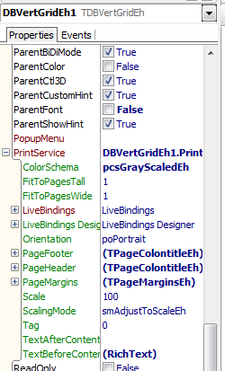

PrintService property contains the following sub-properties:
property name | property type | Description
ColorSchema | TPrintColotSchemaEh | pcsFullColorEh - Full color  pcsAdaptedColorEh - Adapted for printing (for example, the dividing lines in this mode are always printed in black.)  pcsBlackAndWhiteEh - Fully black-and-white drawing.
FitToPagesTall | Integer | When ScalingMode = smFitToPagesEh, FitToPagesTall specifies the number of pages that need to fit the contents of the height.
FitToPagesWide | Integer | When ScalingMode = smFitToPagesEh, FitToPagesTall specifies the number of pages that need to fit the contents of the width.
Orientation | TPrinterOrientation | poPortrait - Portrait orientation sheet.  poLandscape – Landscape page orientation.
PageFooter | TPageColontitleEh | Specifies the texts that will appear in the footer of the page.
PageHeader | TPageColontitleEh | Specifies the texts that will appear in the page header.
PageMargins | TPageMarginsEh | Indent and page headers and footers.
Scale | Integer | It sets out a percentage. Default is 100.
ScalingMode | TScalingModeEh | smAdjustToScaleEh - Scale using the FitToPagesTall and FitToPagesWide properties.  smFitToPagesEh - Scale using the Scale property.
TextAfterContent | TRichStringEh | Rich Text to be printed before the contents of the grid.
TextBeforeContent | TRichStringEh | Rich Text to be printed after the contents of the grid.

Use PrintService.Print and PrintService.Preview methods to print components at Runtime:

DBVertGridEh1.PrintService.Preview;

Use the properties for the print settings as follows:
The header and footer of the page:

property PrintService.PageFooter;
property PrintService.PageHeader;

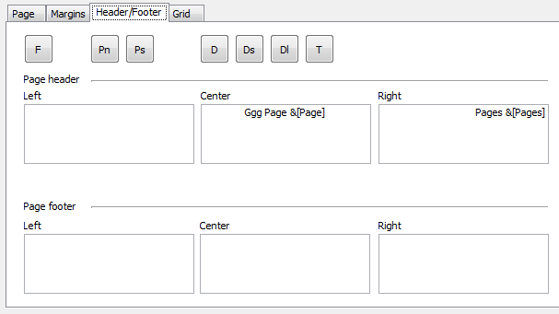

Page margins

property PrintService.PageMargins: TPageMarginsEh;

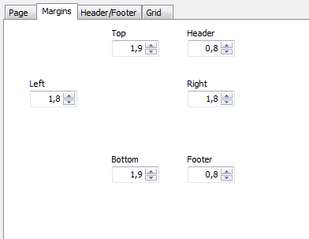

Orientation and Scaling:

property ColorSchema: TPrintColotSchemaEh;
property FitToPagesTall: Integer;
property FitToPagesWide: Integer;
property Orientation: TPrinterOrientation;
property Scale: Integer;
property ScalingMode: TScalingModeEh;

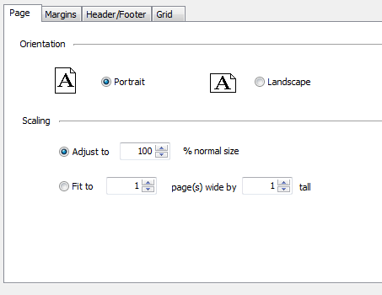

PrintService property contains the following events:
OnBeforePrint;
OnBeforePrintPage;
OnBeforePrintPageContent;
OnPrintDataBeforeGrid;
OnCalcLayoutDataBeforeGrid;

OnAfterPrint;
OnAfterPrintPage;
OnAfterPrintPageContent;
OnPrintDataAfterGrid;
OnCalcLayoutDataAfterGrid;

New features of TPlannerControlEh component
In TPlannerControlEh component it is added the event to set data for hint window (Hints) that appear when mouse you hover over the event area.
OnSpanItemHintShow: TPlannerViewSpanItemHintShowEventEh
Write the event handler to change the text, font and background in the display prompts.
The hint window is appeared when mouse moves and hold over the event area (TPlannerDataItemEh).
In the below example the OnSpanItemHintShow handler adds a new line with text 'NewLine' and sets the hint font in bold style.

procedure TfrFrameOne.PlannerDayViewEh1SpanItemHintShow(
PlannerControl: TPlannerControlEh; PlannerView: TCustomPlannerViewEh;
CursorPos: TPoint; SpanRect: TRect; InSpanCursorPos: TPoint;
SpanItem: TTimeSpanDisplayItemEh; Params: TPlannerViewSpanHintParamsEh;
var Processed: Boolean);
begin
PlannerControl.DefaultFillSpanItemHintShowParams(PlannerView,
CursorPos, SpanRect, InSpanCursorPos, SpanItem, Params);
Params.HintStr := Params.HintStr + sLineBreak + 'NewLine';
Params.HintFont.Style := Params.HintFont.Style + [fsBold];
Processed := True;
end;

On the screen the hint will appear as follows:
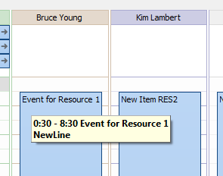

New features of MRUList technology
MRU List is a list of the most recently used values. MRUList is displayed when user type text in the grid editor or TDBEditEh (or inherited component).
In the new version of the library the list of MRUList values can be formed automatically on the basis of a list of unique values in the DataSet.
To activate MRUList set MRUList.Active = True. To specify that the data should be taken from the DataSet set MRUList.ListSourceKind property to lskDataSetFieldValuesEh.
List with values to be displayed when the user begins to type data the text editor.
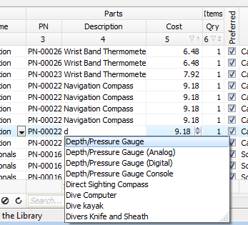

Not all DataSets support access to the internal data structure for a list of unique values of a column.
In the current version of the library MRUList.ListSource Kind = lskDataSetFieldValuesEh mode works for DataSet of TMemTableEh type. In one of the unit for your project it is necessary to add a EhLibMTE module in the uses clause. This module contains a class that is able get unique values for a field.

If your DataSet supports the ability to get a list of unique values for a field, then you can write and register your class inherited from TDatasetFeaturesEh. The implementation of the class it must written of FillFieldUniqueValues function. See the example of the implementation in the EhLibMTE unt.

New events in the TDBGridEh.SearchPanel class
New events are added in the TDBGridEh.SearchPanel class:
OnSearchEditKeyDown
The event occurs when a key is down in a text editor of SearchPanel.
OnSearchEditKeyPress
The event occurs when a key is pressed in a text editor of SearchPanel.
OnSearchEditKeyUp
The event occurs when a key is up in a text editor of SearchPanel.
OnSearchEditChange
The event occurs when the text is changed the editor of SearchPanel.
OnCheckCellHitSearch
The event occurs during the test conditions - of whether or not the specified grid cell meets search condition.
OnGetHighlightStrings
This event occurs when the grid receive a list of strings that need to highlight the cells of the grid as a searching text.

See the example of using events to write an advanced search through the Search Panel in the Folder:
DEMOS\DBGridEh.SearchPanel section Demo3.

Other features of the library
New properties of TDBCheckBoxEh class:
WordWrap: Boolean

--
In TControlEmptyDataInfoEh added property
Color: TColor
In the TDBEditEh, TDBDateTimeEditEh, TDBComboBoxEh, TDBNumberEditEh components with the property EmptyDataInfo you can customize the color control, when its value is empty.

--
New properties of TDBLookupComboboxEh. DropDownBox class:
property RowHeight: Integer;
property RowLines: Integer;

--
New properties of TDBVertGridEh component:
property AllowedOperations: TDBGridEhAllowedOperations

