What's new in EhLib 8

(New features of your applications)

Brief description of new features in this version:
- New components for planning and visual manage of time events
- New components to export DataSet to a text file and import from a text file
- New property - RefLink in the DBGridEh.TColumnEh and DBVertGridEh.TFieldRowEh classes
- Data transfer from DBGridEh and DBVertGridEh into clipboard with format compatible with MS Excel
- Progressbar in the TPivotGridEh that shows a percent for data forming with possibility of interruption the process
- Component that allow to hide other components on the Form at Design-Time
- Export the contents of the TDBVertGridEh component into Xlsx file

New components for planning and visual manage of time events
The library contains a set of components for planning and visual management of time events.
TPlannerDataSourceEh component
TPlannerDataSourceEh component is intended for storing time event objects of TPlannerDataItemEh type.
TPlannerControlEh component
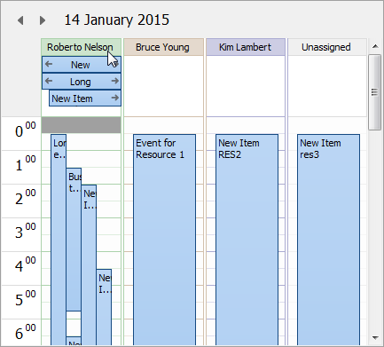
Visual component-container TPlannerControlEh contains a set of visual components of PlannerView type.
Each of the PlannerView components displays a time period and events on it in a specific format – One day, One week, One month etc.
The screenshot on the left the TPlannerControlEh component contains a PlannerView of TPlannerDayViewEh type, which displays a set of events in one day.

In the current version of Library the PlannerView elements may be of the following type:
- TPlannerDayViewEh Displays a period of time of one day and the events that get into it
- TPlannerWeekViewEh Displays a period of time of one week and the events that get into it
- TPlannerMonthViewEh Displays a period of time of one month and the events that get into it
- TPlannerVertDayslineViewEh Displays a time segment of varying lengths in a vertical orientation with the cells of one day long
- TPlannerVertHourslineViewEh Displays a time segment of varying lengths in a vertical orientation with the cells of one hour long
- TPlannerHorzHourslineViewEh Displays a time segment of varying lengths in a horizontal orientation with the cells of one day long
- TPlannerHorzDayslineViewEh Displays a time segment of varying lengths in a horizontal orientation with the cells of one hour long

TPlannerControlEh component contains PlannerView components like just as standard TPageControl component contains a set of TabSheets.
TPlannerCalendarPickerEh component
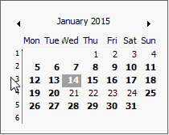
Visual component - calendar, is designed to navigate through the days of the month.
When date is selected a in the calendar component it automatically sets the current day in the binded TPlannerControlEh component. Use TPlannerCalendarPickerEh.PlannerControl property to bind calendar component to the TPlannerControlEh.

When the current period is changed in TPlannerControlEh or TPlannerCalendarPickerEh components the PlannerControl component applies to TPlannerDataSourceEh component to get a list of time event objects (TPlannerDataItemEh) for the desired period.
Use TPlannerControlEh.TimePlanSource to bind PlannerControl and PlannerDataSource.
Loading of time events from the database or other repository.
Time events can be loaded into TPlannerDataSourceEh in the program code using similar code:
PlanItem := PlannerDataSourceEh1.NewItem();
PlanItem.ItemID := MyDataSet1['Id'];
PlanItem.StartTime := MyDataSet1['StartTime'];
...
PlannerDataSource.FetchTimePlanItem(PlanItem);

The second way to load data - through binding DataSet and DataSet fields to a PlannerDataSourceEh.
Use subproperties of TPlannerDataSourceEh.ItemSourceParams property to set bindings.
Assign TPlannerDataSourceEh.ItemSourceParams.DataSet property by the DataSet that hold time events.
Fill TPlannerDataSourceEh.ItemSourceParams.FieldsMap collection to bind properies in TItemSourceFieldsMapItemEh class and fields it DataSet.
Unloading changed items in the database.
With any change in PlannerDataItem element the TPlannerDataSourceEh component fire OnApplyUpdateToDataStorage event where you need to write code to transfer a property of the changed PlannerDataItem item to the data storage.
Event handler code might look like this:
procedure TfrFrameOne.TimePlanSourceEh1ApplyUpdateToDataStorage(
TimePlanSource: TPlannerDataSourceEh; PlanItem: TPlannerDataItemEh;
UpdateStatus: TUpdateStatus);
begin
if UpdateStatus = usModified then
begin
if mtPlannerData.Locate('Id', PlanItem.ItemID, []) then
begin
mtPlannerData.Edit;
mtPlannerData['StartTime'] := PlanItem.StartTime;
mtPlannerData['EndTime'] := PlanItem.EndTime;
mtPlannerData['Title'] := PlanItem.Title;
mtPlannerData['Body'] := PlanItem.Body;
mtPlannerData['AllDay'] := PlanItem.AllDay;
mtPlannerData['ResourceID'] := PlanItem.ResourceID;
mtPlannerData.Post;
end else
raise Exception.Create('Can''t locate a record with "Id"='+VarToStrDef(PlanItem.ItemID, '<Null>'));

In this example, the modified data of PlanItem time event is transferred to the record mtPlannerData DataSet.
Resources and events.
There are resources in the TPlannerDataSourceEh component. Each time event can be assigned to a one of a resource from resource collection. Typically, a collection of resources is filled before completing the collection of time events - PlanItems.
Use similar code to fill a resource collection of TPlannerDataSourceEh component:
with TimePlanSourceEh1.Resources.Add do
begin
Name := mtResource.FieldByName('Name').AsString;
ResourceID := i;
end;

See a demo project in the folder <EhLib Archive>/DEMOS/PlannerEh.MainDemo

New components to export DataSet to a text file and import from a text file
The library contains components for uploading data from the DataSet in a text file and to load from a text file.
The data can be uploaded to the file with values delimited format or in the form of fixed length for each field.
When importing and exporting data, you can specify additional settings such as data format: The format of dates, date separator, time format, time separator, decimal separator, etc.
TDataSetTextExporterEh component
At Design-Time set the required properties of the TDataSetTextExporterEh component and call method ExportToFile or ExportToStream.
procedure TDataSetTextExporterEh.ExportToFile(AFileName: String; AppendToFile: Boolean = False);
or
procedure TDataSetTextExporterEh.ExportToStream(AStream: TStream);
The first method records data in a file, but the second method in the stream. If you set AppendToFile = True, then the data will be added to the file instead of overwriting.
Properties of the TDataSetTextExporterEh component:
Property Name | Property Type | Description
DataSet | TDataSet | DataSet which will be used as a source of export data.
Encoding | TExportImportEncodingEh | Encoding, in which the data is uploaded  TExportImportEncodingEh type contains the following values  eieAutoEh - Unload data in the format specified by the global variable DefaultExportEncoding.  eieUTF7Eh - Unload the data format in the format eieUTF7Eh.  The remaining value: eieUTF8Eh, eieUnicodeEh, eieBigEndianUnicodeEh, eieANSIEh, eieASCIIEh.
ValueSeparationStyle | TValueSeparationStyleEh | Style of value separating when exporting the data. The Style can have next values:  vssFixedPositionAndSizeEh - fields have a fixed size defined by TFieldsMapItemEh. FileFieldLen  vssDelimiterSeparatedEh - Fields are separated by a separator given by ValueDelimiter property.
ValueDelimiter | Char | Separator of field values in the output data stream.
QuoteChar | Char | Quotation mark, which is used to record values.
IsExportFieldNames | Boolean | Specifies the need to record the field names in the first row of the export file.
ExportValueAsDisplayText | Boolean | Property specifies the style of the translation field values in the text representation. If ExportValueAsDisplayText = True, then to retrieve data from the field will be used Field property Field.DisplayText, otherwise it will use the property Field.Value.
ValueExceedsSizeLimitAction | TValueExceedsSizeLimitActionEh | The action taken, if the length of the field value is greater than the length specified in the element format TFieldsMapItemEh.FileFieldLen.
ExportRecordsCount | Integer | Number of unloaded records. A value of -1 specifies that it is necessary to unload all records DataSet.
ExportFormats | TExportImportFormatsEh | Sets the formats and separators for the data type of Date, Time and Number.
FieldsMap | TFieldsMapCollectionEh | Specifies the collection of items TFieldsMapCollectionEh. Each element of the collection defines the parameters of the field in the export file. If the collection FieldsMap contains no data, it will be uploaded in all fields DataSet.

Основные события компоненты TDataSetTextExporterEh
Property Name | Property Type | Description
OnStartExport | TNotifyEvent | Occurs before exporting the data
OnFinishExport | TNotifyEvent | Occurs after exporting data
OnExportTitle | TDataSetTextExporterExportLineEventEh | Occurs when exporting the column headings
OnExportRecord | TDataSetTextExporterExportLineEventEh | Occurs when exporting a single record DataSet. In the handler takes a parameter of type StreamWriter TStreamWriter, which you can use to record additional information flow, make full use of your algorithm data recording method of recording or cause a default Exporter.DefaultExportRecord (StreamWriter);
OnTruncateTitleField | TTruncateTitleFieldEventEh | Occurs when the need to cut off the name of the header field
OnTruncateDataField | TTruncateDataFieldEventEh | Occurs when necessary, trim the value of the field
OnGetFieldSize | TGetFieldSizeEventEh | Occurs to get the size of the field
OnFormatExportValue | TFormatTextExportValueEventEh | Occurs when exporting a single field value. In the event handler you can write the exported value in the parameter Value. If you override the default handler formatting values, set the parameter as Processed to True.

TDataSetTextImporterEh component
At Design-Time set the required properties of the TDataSetTextImporterEh component.
At Run-Time call the method
procedure TDataSetTextImporterEh.ImportFromFile(AFileName: String);
or
procedure TDataSetTextImporterEh.ImportFromStream(AStream: TStream);

See the demo project in the folder <EhLib Archive>/DEMOS/PlannerEh.DataSetImpExp

New property - RefLink in the DBGridEh.TColumnEh and DBVertGridEh.TFieldRowEh classes
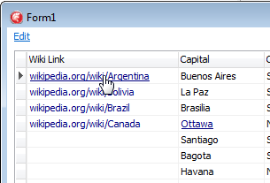
New property RefLink of Boolean type allows you to specify that a text or a picture in a grid cell must be shown as a "Link".
I.e. when mouse hover the text the mouse cursor icon change to the type of "index finger" and the text is drawn in Underline style.

Mouse click fire TAxisBarEh.OnCellDataLinkClick event.

It is possible to define RefLink regime individually for each record cell in the Grid.

Write TAxisBarEh.OnGetCellParams event handler and set Params.TextIsLink to True for required records.

See a demo project in the folder <EhLib Archive>/DEMOS/CellDataIsLink

Data transfer from DBGridEh and DBVertGridEh in MS Excel via the clipboard data format with support
When the data is copied to clipboard in a DBGridEh or a DBVertGridEh component, it stored data in a "XML Spreadsheet" format. This format is recognized by MS Excel and allows you to transfer data to MS Excel with preserving fonts, colors and data types.
The data is copied to the clipboard with this format automatically when CopyAction operation is allowed in the DBGridEh or DBVertGridEh component.
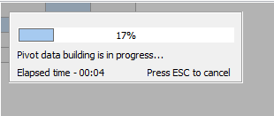
Progressbar in the TPivotGridEh that shows a percent for data forming
In TPivotGridEh when forming of data takes too long tine progressbar indicator is shown with the possibility of interruption by pressing ESC key.

Hide form components at Design-Time
TCompoManEh component
TCompoManEh component is intended for use only in the Design-Time.
TCompoManEh hides other components form at design time, thus giving the opportunity to see the design form as close as possible to the design mode Run-Time.

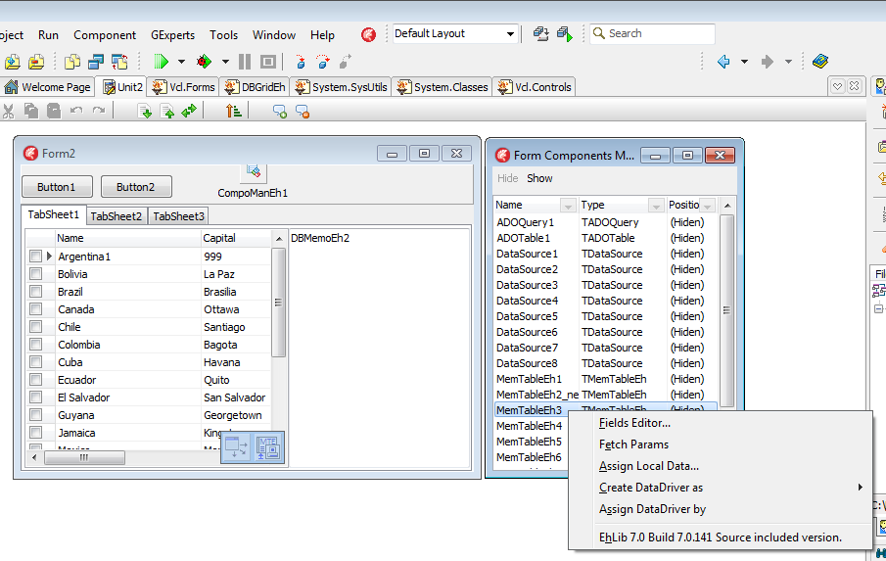
On screen above the form is shown at Desig-Time. All components, except for the TCompoManEh, are hidden by a component editor CompoManEh1. The right side of the screenshot you can see a window with a list of hidden components. The window opens when you double-click on CompoManEh1. The window contains all the components form TForm2. Right-click on the component shows a Popup menu editor opens for the selected component.

Export the contents of the TDBVertGridEh components into Xlsx file
There are a class and the procedure is added in module DBVertGridEhImpExp.pas for "direct" export contents of a TBVertGridEh into Xlsx file.

TDBVertGridExportToXlsxEh = class;

Class implements export data from VertGridEh to the file of Xlsx format (file format MS Excel). Unloading is carried out directly without using additional libraries and OLE objects. Full functional process can work only in Delphi XE2 or higher. To make it works in the earlier versions of Delphi you must use the third-party libraries to form a Zip file format of version 2.

Next procedure can be used for unloading the data:

procedure ExportDBVertGridEhToXlsx(DBVertGridEh: TCustomDBVertGridEh; const FileName: String);

