What's new in EhLib 7.
(New features of your applications)

Brief description of new features in this version:
✓ Supports LCL Library (Lazarus, Free Pascal).
✓ New components:
✓ Component TDBMemoEh
✓ Component TDBImageEh
✓ Component TDBRadioGroupEh
✓ Component TDBRichEditEh
✓ Export DBGridEh to Xlsx format.
✓ New DefaultAction property in the TEditButtonEh class.
✓ In DBGridEh:
✓ Interactive edit buttons when displaying of graphics data
✓ Width and height of scrollbar areas
✓ Advanced drop-down list box to filter the data in the grid (STFilter) with possibility to search and filter data.
✓ New property - PopupMenuParams and customizing of the global drop-down menu for all the Grids of a project using TDBGridEhCenter class.
✓ In IDE components are located on the two tabs in the component palette.
✓ Global class - TDBAxisGridEhCenter to implement a single point of modification the behavior of DBGridEh and DBVertGridEh components.
✓ ControlLabel – inline associated label for EhLib edit controls.
✓ New components for the cross-tabulation data analysis: TPivotGridEh, TPivotDataSourceEh, TPivotGridToolBoxEh.

 Support of LCL Library (Lazarus, Free Pascal)
EhLib 7 supports LCL framework (Lazarus, Free Pascal) for Win32 platform.
Read details of the LCL support (Lazarus) in the file «Lazarus/readme.txt»

New components for editing a scalar data values
TDBMemoEh component.
The component is designed for editing a multiline text data.
Component can operate in Data-aware mode (connected to DataSet) and not Data-aware mode.
Properties and methods are similar to the standard TDBMemo component.
In addition, the component contains the following additional properties:
AlwaysShowBorder
DynProps
EditButtons
EmptyDataInfo
Flat
HighlightRequired
Images
MRUList
Tooltips
When the Edit button is clicked, the DropDownForm is it opened for extended text editing.

TDBImageEh Component
The component is designed for editing an graphic image.
Component can operate in Data-aware mode (connected to DataSet) and not Data-aware mode.
Properties and methods are similar to the standard TDBImage component.
In addition, the component contains the following additional properties:
AlwaysShowBorder
DynProps
EditButtons
EmptyDataInfo
Flat
HighlightRequired
MRUList
Tooltips
When the Edit button is clicked, the DropDownForm is it opened for editing the graphic image.

TDBRadioGroupEh Component
TDBRadioGroup represents a group of radio buttons.
Component can operate in Data-aware mode (connected to DataSet) and not Data-aware mode.
Properties and methods are similar to the standard TDBRadioGroup component.
In addition, the component contains the following additional properties:
DynProps

TDBRichEditEh Component
The component is designed for editing rich text memos.
Component can operate in Data-aware mode (connected to DataSet) and not Data-aware mode.
Properties and methods are similar to the standard TDBRichEdit component.
In addition, the component contains the following additional properties:
AlwaysShowBorder
DynProps
EditButtons
EmptyDataInfo
Flat
HighlightRequired
Images
MRUList
Tooltips
When the Edit button is clicked, the DropDownForm is it opened for editing the rich text memo.

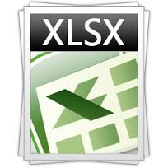 Export DBGridEh in Xlsx file
New global class and procedure are added in the DBGridEhImpExp.pas module for export data from a grid to Xlsx format file.

TDBGridEhExportAsXlsx = class;

Class implements export data from DBGridEh to a Xlsx format file. Export is carried out directly in a file without using external libraries and OLE objects. The сomplete unloading works in Delphi versions since Delphi XE2. To export data in earlier versions of Delphi you must use third-party functions for the making Zip file of version 2.

procedure ExportDBGridEhToXlsx (DBGridEh: TCustomDBGridEh; const FileName: String; Options: TDBGridEhExportAsXlsxOptions; IsSaveAll: Boolean = True);

 New property DefaultAction in TEditButtonEh class
DefaultAction property is added to TEditButtonEh class.
TEditButtonEh class is used in such components as TColumnEh DBGridEh, TFieldRowEh for DBVertGridEh, DBEditEh.EditButtons [i], DBNumberEditEh.EditButton, DBNumberEditEh.EditButtons [i], DBDataTimeEditEh.EditButton, DBDataTimeEditEh.EditButtons [i],

Property determines whether to perform the default action when EditButton is clicked. Default actions depends of components. For example, for DBNumberEditEh default action will be - opening the drop-down calendar. In the other components it will be an over popup window for editing values. By setting DefaultAction to False you cancel opening a dropdown box or other default action.

New features of DBGridEh
Interactive edit buttons when displaying of graphics data

When displaying the image data into a grid cell (BMP, JPG, PNG, etc.) the grid enables to push edit button without going into a text editor. By default, if OnEditButtonClick event is not assigned then the grid opens a dialog for editing picture.

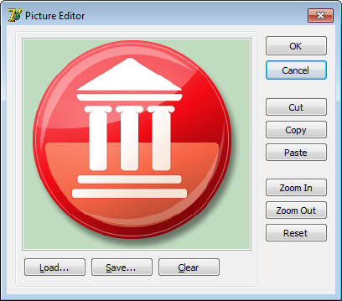

Default action for edit buttons.
If an edit button is visible, but the event of button pressing is not written, then the control calls the default action. The default action depends on a type Field that is assigned to a column. For numeric types, it opens a drop-down calculator, for date fields it opens a drop-down calendar. For text fields, it opens extended text editing form.

Width and height of scrollbar areas

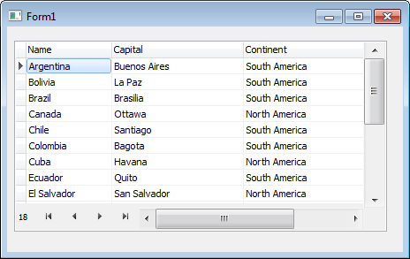 | In the grid, there are new properties: HorzScrollBar.Heigt and VertScrollBar.Width, which control the height of a horizontal scroll area and width of the vertical.

Advanced drop-down list box to filter the data in the grid (STFilter) with possibility to search and filter items in the list.
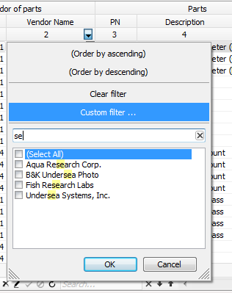 | In the popup window DropDownFilterList of STFilter added an ability to search and filter items in the list.

New property - PopupMenuParams and customizing of the global drop-down menu for all the DBGrids of a project using TDBGridEhCenter class.
In TDBGridEh added a PopupMenuParams property to control of building PopupMenu in the grid. By default, the grid uses the following properties to determine which PopupMenu is displayed when the right mouse button is pressed: TDBGridEh.PopupMenu, TColumnEh.PopupMenu, TColumnEh.Title.PopupMenu. Using sub properties of TDBGridEh.PopupMenuParams properties you can define how the PopupMenu is build.
PopupMenuParams property contains the following sub-properties:
BuildMenuOnPopup: Boolean – Defines if it is necessary to build a PopupMenu or use existing one before being showen. If BuildMenuOnPopup = True, then the grid will form a new PopupMenu before it is displayed. This allows you to create new elements of PopupMenu or change/delete existing PopupMenu items before displaying on the screen. Thus, the elements of PopupMenu can be formed dynamically depending on the menu position and other conditions affecting the items list.
UseGlobalMenu: Boolean - Specifies whether to add global menu items to the PopupMenu. Elements of a global menu is added in the procedure TDBGridEhCenter.BuildCellPopupMenu. By default, BuildCellPopupMenu adds nothing. You can write your own TDBGridEhCenter class and override BuildCellPopupMenu to add new elements to a PopupMenu for every DBGrid of the project. Register your TDBGridEhCenter using global function – SetDBGridEhCenter.
In IDE components are located on two tabs in the component palette.
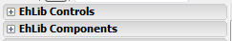
Starting with EhLib version 7, IDE library components are located on the two tabs:
EhLib Controls - Visual Library Components - TDBGridEh, TDBEditEh, ...
EhLib Components - not visual library components - TDBSumList, TPrintDBGridEh, ...

Global class - TDBAxisGridEhCenter to implement a single point of modification the behavior of DBGridEh and DBVertGridEh components.
A global class TDBAxisGridEhCenter and global functions added in the DBAxisGridsEh.pas module.
function SetDBAxisGridEhCenter (NewGridCenter: TDBAxisGridEhCenter): TDBAxisGridEhCenter;
function DBAxisGridEhCenter: TDBAxisGridEhCenter;
They are designed to implement a single point on the modification of some parts of behavior in the DBGridEh and DBVerGridEh components. For example, rewriting method TDBAxisGridEhCenter.EditButtonDefaultActionForImage you can change the implementation of Opening edit form for cells with graphical data in all Grids of your application.
Here is some methods that can be overridden in TDBAxisGridEhCenter class:
procedure EditButtonDefaultAction (...); virtual; - is called on pressing EditButton in a cell of TDBGridEh or TDBVertGridEh components . You can override this virtual procedure to write your actions to process pressing of the EditButton. To override the action for individual grid it is needed to write the OnEditButtonDown or OnEditButtonClick event.
procedure EditButtonDefaultActionForImage (...); virtual; is called on pressing of EditButton in a cell of TDBGridEh or TDBVertGridEh component for fields of Blob type which BlobType propert is ftGraphic.
procedure EditButtonDefaultActionText (...); virtual;is called on pressing of EditButton in a grid cell for fields of text types.
procedure FormSystemPopupMenuForColumn (...); virtual; is called to form Popup menu that appears when clicking on cell EditButton of TDBGridEh or TDBVertGridEh class. In the current implementation, the procedure is called only for graphic Blob fields.
If you want write special actions on these event you need to write new class inherited from TDBAxisGridEhCenter and register it as new default AxisGridCenter using ... function.
ControlLabel - inline associated label for EhLib controls.
New property - ControlLabel is added in components TDBEditEh, TDBNumberEditEh, TDBComboBoxEh, TDBMemoEh, TDBLookupComboboxEh, TDBImageEh, TDBRichEditEh. Subproperies of ControlLabel property controls the special text next to the edit control. ControlLabel class is of TLabel type. It retain it position near the master control to which it is attached. Combination of TDBEditEh + ControlLabel works with the principle as standard TLabeledEdit control.
By default the ControlLabel is not visible. To make ControlLabel visible it is needed to set EditControl.ControlLabel.Visible to True.
If EditControl is bind to a DataSet field then ControlLabel shows Field.DisplayName as to its Caption text.
To configure location properties ControlLabel, use subproperties of ControlLabelLocation property:
property Position: TLabelPositionEh - position relative to the master control.
TLabelPositionEh = (lpAboveLeftEh, lpAboveCenterEh, lpAboveRightEh, lpBelowLeftEh, lpBelowCenterEh, lpBelowRightEh, lpLeftTopEh, lpLeftTextBaselineEh, lpLeftCenterEh, lpLeftBottomEh, lpRightTopEh, lpRightTextBaselineEh, lpRightCenterEh, lpRightBottomEh);
property Spacing: Integer - the indentation from the master control for the first coordinate axis.
property Offset: Integer - offset relative to the second coordinate axis of the master control.
property LabelSpacingBound: TSpacingBoundEh - Specifies the Label border which is used to measure distance specified by Spacing property.
TSpacingBoundEh = (sbNearBoundEh, sbFarBoundEh);
sbNearBoundEh - Spacing distance is relative to the near border of a Label control.
sbFarBoundEh - Spacing distance is relative to the far border of a Label control.

Here are the typical sets of ControlLabelLocation subproperty values:
 | ControlLabelLocation.LabelSpacingBound = sbNearBoundEh  ControlLabelLocation.Spacing = 3  ControlLabelLocation.Position = lpAboveLeftEh
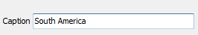 | ControlLabelLocation.LabelSpacingBound = sbNearBoundEh  ControlLabelLocation.Spacing = 3  ControlLabelLocation.Position = lpLeftTextBaselineEh
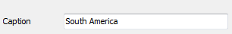 | ControlLabelLocation.LabelSpacingBound = sbFarBoundEh  ControlLabelLocation.Spacing = 80  ControlLabelLocation.Position = lpLeftTextBaselineEh

Components for the cross-tabulation data analysis
TPivotDataSourceEh – component for storing Pivot Data.
TPivotGridEh - component to show and analyze pivot date.
TPivotGridToolBoxEh – component to control and adjust of pivot data in the PivotDataSource component.

How to work with the components of the data analysis.

Follow next steps to create a simple Form for display summary information:

1. Put and setup a DataSet on the form. This DataSet provides data for PivotDataSource.
2. Put PivotDataSource component on the Form .
3. Set the property PivotDataSource.DataSet to the DataSet that is configured at the step 1.
4. Place PivotGridEh and PivotGridToolBoxEh controls on the Form.
5. Set properties PivotGridEh.PivotDataSource and PivotGridToolBoxEh.PivotDataSource to the PivotDataSource that wad configured at the step 2.

The following steps are usually performed at the Run-Time.
6. Create a structure of the internal table buffer in PivotDataSource based on fields of DataSet or from scratch.
PivotDataSourceEh1.PivotFields.RebuildPivotFields;
7. Load data from the DataSet in PivotDataSource.
PivotDataSourceEh1.CreateAndFillSourceTable;
8. Setup axises and values for pivot data.
PivotDataSourceEh1.ColumnFields.Add('SaleDate.Year');
PivotDataSourceEh1.RowFields.Add('ShipVIA');
with PivotDataSourceEh1.ValueFieldDefs.Add do
begin
PivotFieldName := 'AmountPiad';
SumFunction := svtSumEh;
end;

Usually this data are stored in the configuration file or in the database.
9. Form a pivot data.
PivotDataSourceEh1.BuildPivotData;

Look at a demo project of using component for the cross-tabulation data analysis in the EhLib archive:
<EhLib archive>\Demos\PivotGridEh.SimpleDemo\PivotGridEh.SimpleDemo.dpr
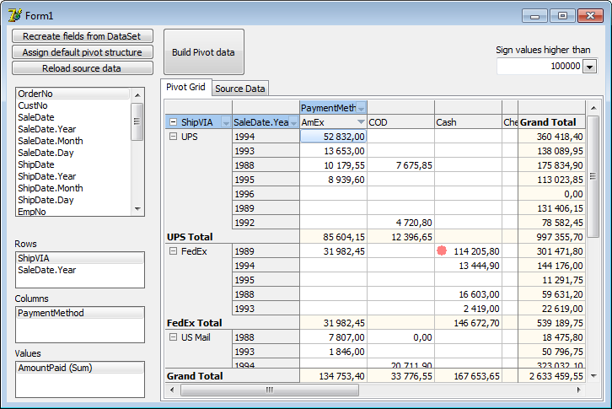

Other capabilities of the library
Added OnNavigatorPanelButtonClick event in the DBGridEh component.

property OnNavigatorPanelButtonClick: TDBGridNavigatorPanelButtonClickEventEh
TDBGridNavigatorPanelButtonClickEventEh = procedure (Sender: TCustomDBGridEh; AButton: TNavigateBtnEh; var Processed: Boolean) of object;

The event is called when user press any of the buttons in the embedded navigator panel (see HorzScrollBar.ExtraPanel property). AButton parameter defines a button type. Set Processed argument to True to prevent the execution of the default button action.

New modules
In the library were added the following new modules:
EhLibSelectFromListDesignEh.pas – A design time module.
EhLibXmlConsts.pas – Defines constants for export data in Xlsx format.
FilterDropDownFormsEh.pas - Defines drop-down box to filter data in DBGridEh using SubTitleFilter.
GridToolCtrlsEh.pas - Contains utility classes for TCustomGridEh.
MemoEditFormsEh.pas - Defines a text editor window that is shown on click of EditButton in the TDBMemoEh component.
PictureEditFormsEh.pas - Defines a graphic editor window that is shown on click of the button in the EditButton TDBImageEh component.
RichEditFormsEh.pas - Defines a Rich Text Editor Window that is shown on click of the button in the EditButton TDBRichEditEh component.

Changes in modules
The module GridsEh.pas
TGridOption type renamed to TGridOptionEh. All values ​​of type suffixed Eh.
TGridDrawInfoEh type removed from the module.
CalcMaxTopLeft, CalcDrawInfoXY, MoveAndScroll, CalcDrawInfo methods removed of TCustomGridEh class. Instead, use HorzAxis and VertAxis properties.
FixedRows and FixedCols properties renamed to FixedColCount and FixedRowCount respectively.
Added new properties: FrozenColCount, FrozenRowCount, RolColCount, RolRowCount.
ScrollBars property is removed from TCustomGridEh class. Use the new properties: VertScrollBar and HorzScrollBar.
TGridState type renamed to TGridStateEh.
Code Examples that demonstrate new capabilities of the library
<EhLib Archive>\Demos\MainDemo\Project1.dpk Project
In the project on the tab «Edit Controls 2" is shown new data editing components: TDBMemoEh, TDBImageEh, TDBRichEditEh. On EditButton press they open Advanced Editing Windows. Type of the Window depends on the EditButton style. If EditButton is of DropDownCombo style then DropDownForms is shown. If EditButton is if Dots style then a usual dialog Form is shown.
<EhLib Archive>\Demos\DBGridEh.PopupMenuParams\Project1.dpk Project
The project demonstrates the possibility of building a PopupMenus for Grids.

<EhLib Archive>\Demos\DBGridEh.ExportToXlsx\Project1.dpk Project
The project demonstrates of using a procedure ExportDBGridEhToXlsx.

